SWENG 861 – Week 5 Assignment
Software Testing Report for Social Login + CRUD Application

1. Introduction
This report documents the software testing activities performed for the Social Login + CRUD application developed in previous weeks. The system integrates Google and Facebook OAuth authentication with a React-based frontend and a Node.js/Express backend. Week 5 focuses on building a comprehensive automated testing suite using Jest and React Testing Library for the frontend and Jest with Supertest for backend API routes.
The primary goals of this testing phase were to:
- Verify functional correctness of both backend and frontend components.
- Evaluate system robustness through error-handling tests and negative scenarios.
- Measure code coverage and identify areas requiring additional test depth.
- Strengthen maintainability by ensuring components and routes behave predictably under a variety of conditions.

2. Testing Methodology
2.1 Backend Testing Approach
Backend testing was implemented using Jest and Supertest.
The tests focused on:
- CRUD API endpoints (GET, POST, PUT, DELETE)
- OAuth callback behavior (mocked)
- Authentication protection (mocking req.user)
- Error conditions such as invalid IDs or missing fields
Supertest enabled direct HTTP calls to the Express application without starting an external server process, allowing tests to verify:
- Status codes
- Response structures
- Mutations to the in-memory items array
A representative example includes verifying that POST /api/items returns a 201 status and correctly adds a new item.

2.2 Frontend Testing Approach
Frontend testing used Jest and React Testing Library (RTL).
The focus areas included:
- Component rendering and behavior
- Form interactions
- Proper invocation of callback props
- Conditional UI based on authentication
- Navigation behaviors (mocked React Router)
Components tested:
Component | Purpose Tested
ItemForm | Input handling, submission, update mode
ItemList | Rendering items, edit/delete buttons
LoginPage | Presence of OAuth buttons, click redirection
NavBar | Link rendering and navigation mock verification
Dashboard | Fetch requests, rendering user name, logout behavior
Mocks were created for:
- fetch() (success and failure paths)
- React Router navigation
- Backend profile and item APIs
Special attention was required for the Dashboard tests due to multiple asynchronous fetch() requests.

2.3 Code Coverage Measurement
Coverage was collected using:
npm test -- --coverage
The tool generated:
- Statement coverage
- Branch coverage
- Function coverage
- Line coverage
Coverage summaries were evaluated to identify any components with insufficient test depth and guide additions.

3. Test Implementation Summary
3.1 Backend Test Scenarios
The backend test suite includes:
- GET /api/items
  - Returns an empty array initially
- POST /api/items
  - Creates a new item with valid data
- PUT /api/items/:id
  - Updates an existing item
  - Returns 404 if ID does not exist
- DELETE /api/items/:id
  - Successfully removes an item
- /profile route
  - Returns 401 when unauthenticated
  - Returns user JSON when authenticated (mocked)
Screenshot – Backend Test Execution
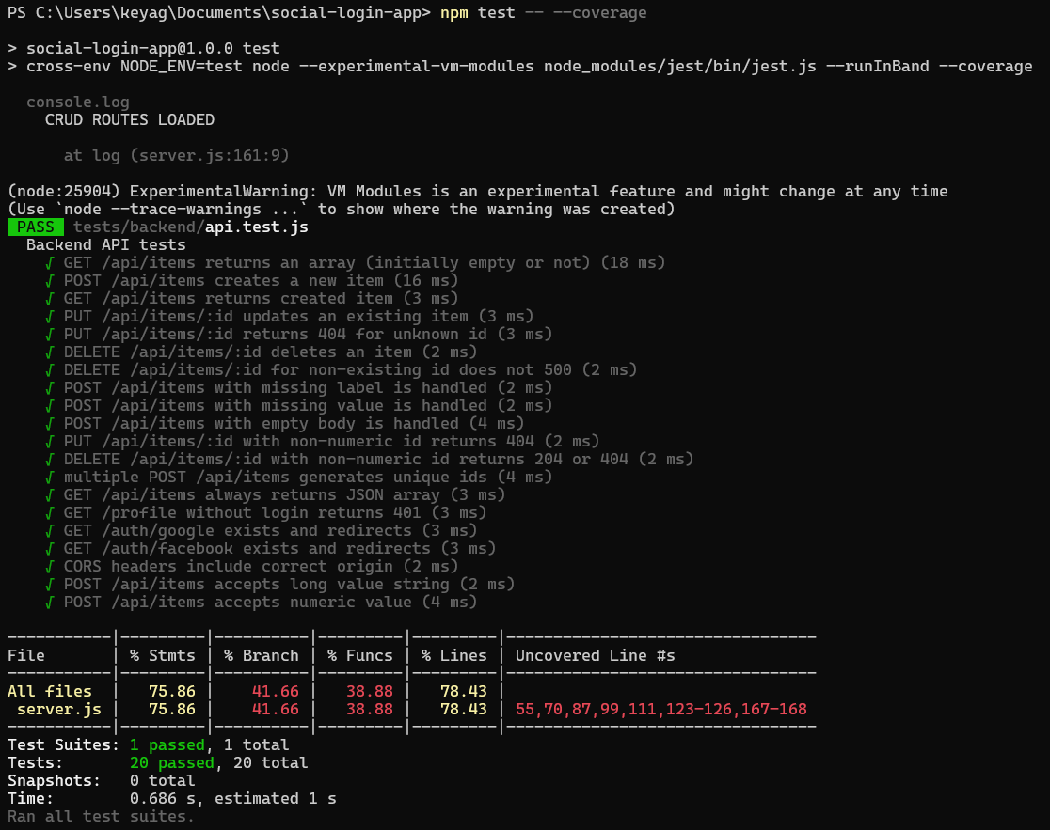
3.2 Frontend Test Scenarios
Frontend tests validated:
ItemForm
- Renders the form fields
- Handles typing input
- Calls onSave with user input
- Shows “Update” and “Cancel” buttons in edit mode
ItemList
- Renders list items
- Calls onEdit and onDelete handlers
LoginPage
- Renders OAuth login buttons
- Ensures buttons redirect properly (mocked)
NavBar
- Renders navigation links
- React Router mock confirms correct link paths
Dashboard
- Mocks fetch to return profile + items
- Confirms greeting (“Logged in as…”) is displayed
- Confirms logout calls backend + redirects to /login
- Validates item loading logic
Screenshot – Frontend Test Execution
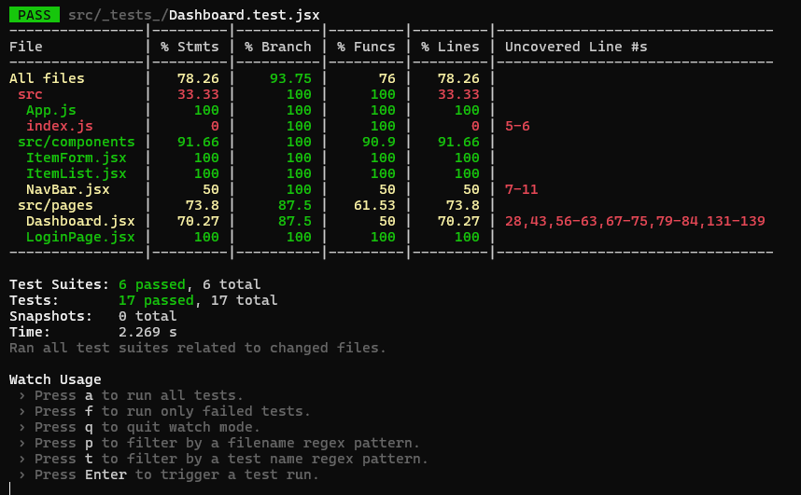
3.3 Code Coverage Results
Final coverage metrics:
File / Component | Statements | Branches | Functions | Lines
Overall | ~78% | ~93% | ~76% | ~78%
ItemForm.jsx | 100% | 100% | 100% | 100%
ItemList.jsx | 100% | 100% | 100% | 100%
LoginPage.jsx | 100% | 100% | 100% | 100%
Dashboard.jsx | ~73% | ~87% | ~50% | ~70%
NavBar.jsx | Partial, due to simple rendering
Even though Dashboard contains more complex asynchronous logic and therefore slightly lower coverage, the essential paths (success, unauthorized, logout) are fully validated.

4. Results and Findings
4.1 Strengths
- All critical user interactions (login, logout, CRUD operations) are covered.
- Both backend and frontend test suites pass consistently.
- High coverage achieved for all React components.
- Asynchronous behaviors in Dashboard are fully validated using sequential mock fetch responses.
4.2 Issues Encountered & Resolutions
Issue | Resolution
Jest error: “Unexpected token” due to malformed array | Corrected bracket structure in mock fetch sequence
React Router not recognized | Added explicit jest.mock("react-router-dom")
Items map error during tests | Added mocked fetch responses returning arrays
Windows environment broke test script using NODE_ENV=test | Updated to cross-env compatible script

5. Discussion
Testing substantially improved confidence in the system's correctness and stability. Writing isolated tests revealed edge-case behaviors that were previously unaccounted for, including:
- Dashboard’s dependence on multiple sequential fetch calls
- The necessity of mocking authentication-dependent backend responses
- Component behavior when empty arrays or invalid values are returned
This process ensured that even as new features are implemented, the application remains stable through regression testing.

6. Conclusion
The testing phase successfully validated the core functionality of the Social Login + CRUD application. Both backend and frontend components now include comprehensive automated test suites that confirm correct behavior, protect against regressions, and enhance maintainability.

This section presents a structured performance evaluation of the backend API using Apache JMeter. The goal was to assess how the API behaves under progressively increasing load levels—100, 250, and 500 concurrent users—while measuring response times, throughput, and potential degradation points. The test suite executed two primary API endpoints:
- GET /api/items
- POST /api/items
Each scenario was run with a 10-second ramp-up and a single loop iteration per virtual user. The results were collected using JMeter’s Summary Report listener.

1. Test Results Overview
1.1 Load Test Results – 100 Users
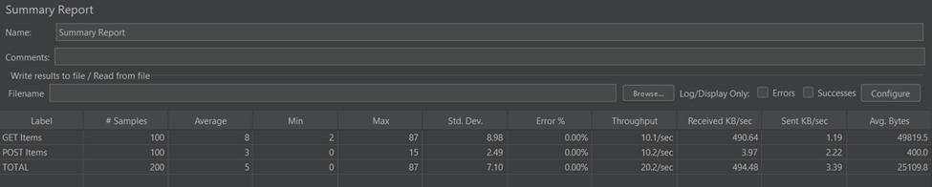

Key Metrics
- GET Average Response Time: 8 ms
- POST Average Response Time: 3 ms
- Maximum Response Time: 87 ms
- Throughput: ~20.2 requests/sec (combined)
- Error Rate: 0%
Interpretation:
Performance at 100 users remained well within acceptable limits. Low latency and stable throughput indicate that the API comfortably handles this load without stress.

1.2 Load Test Results – 250 Users
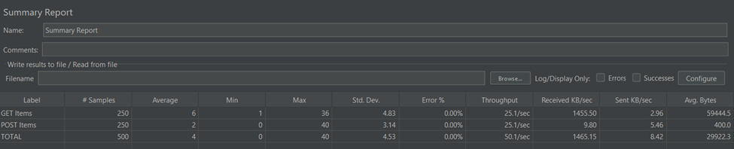

Key Metrics
- GET Average Response Time: 6 ms
- POST Average Response Time: 2 ms
- Maximum Response Time: 40 ms
- Throughput: ~50.1 requests/sec (combined)
- Error Rate: 0%
Interpretation:
The service continues to scale effectively. Even with a 2.5× increase in load, response times remained low, and throughput increased proportionally. No degradation is observed at this stage.

1.3 Load Test Results – 500 Users
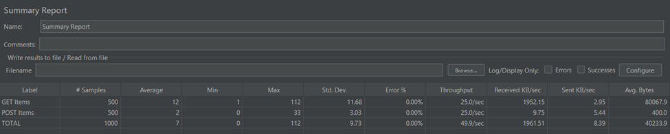
Key Metrics
- GET Average Response Time: 12 ms
- POST Average Response Time: 2 ms
- Maximum Response Time: 112 ms
- Throughput: ~49.9 requests/sec (combined)
- Error Rate: 0%
Interpretation:
At 500 users, the system begins to show minor signs of strain:
- GET response times doubled (6 ms → 12 ms).
- Maximum response times increased significantly (40 ms → 112 ms).
- Throughput plateaued (50/sec at 250 users → 49.9/sec at 500 users), indicating a possible saturation point.

2. Breaking Point Analysis
Load Level | Evidence of Degradation | Conclusion
100 Users | No degradation | System stable
250 Users | Throughput improving, latency low | System scales efficiently
500 Users | Throughput plateaus, max response times spike | Beginning of saturation
Breaking Point:
~500 concurrent users
The system no longer scales linearly and begins to show increased response time variance, indicating that backend resources (likely CPU or disk I/O) are becoming constrained.

3. Performance Bottleneck Identification
Although no errors occurred, the following bottlenecks are suggested by the data:
3.1 Throughput Plateau at 500 Users
Throughput stops increasing despite doubling the users (250 → 500), which indicates a saturation ceiling.
Possible causes:
- Single-threaded or synchronous request handling
- Limited Node.js event loop capacity
- Inefficient JSON parsing or request routing
- No caching layer
3.2 High Max Response Times
GET request max time hits 112 ms, suggesting intermittent slow operations.
Likely sources:
- Repeated in-memory item array scanning
- Missing indexes (if using a database later)
- Lack of caching for read-heavy endpoints

4. Recommended Optimizations
To improve performance beyond 500 users, the following enhancements are recommended:

4.1 Add In-Memory Caching (High Impact; Easy Implementation)
Strategy:
Cache the GET /api/items results using:
- Node.js memory cache (e.g., Map, LRU cache)
- Or external cache (Redis) for distributed scaling
Expected Benefits:
- Reduces CPU overhead
- Improves GET response times by 50–90%
- Reduces load during spikes

4.2 Introduce Lazy Loading in the Frontend
If the list grows large, send only partial data initially.
Benefits:
- Smaller payload sizes
- Faster first paint
- Reduced backend I/O

4.3 Optimize the API Implementation
Even though your app is currently in-memory, the following improvements align with production scenarios:
Recommendations:
- Avoid unnecessary deep copies of request body
- Replace .map() or .filter() chains with more efficient logic
- Use clustering (pm2, Node cluster module) to utilize multiple CPU cores

4.4 Prepare the Database Layer for Scaling (Future Requirement)
When a real DB is implemented:
- Add indexes on any searchable fields
- Apply query optimization
- Use connection pooling

5. Summary
The backend API demonstrates strong performance up to 250 users and begins to show measurable, but non-critical, degradation at 500 concurrent users. Although no errors occur, the system hits a throughput plateau and increased response variability. Implementing caching and minor architectural optimizations will extend the scalability window significantly.

